**BT 307 Lab 07**

1. Harsh Arora , 200106034
2. 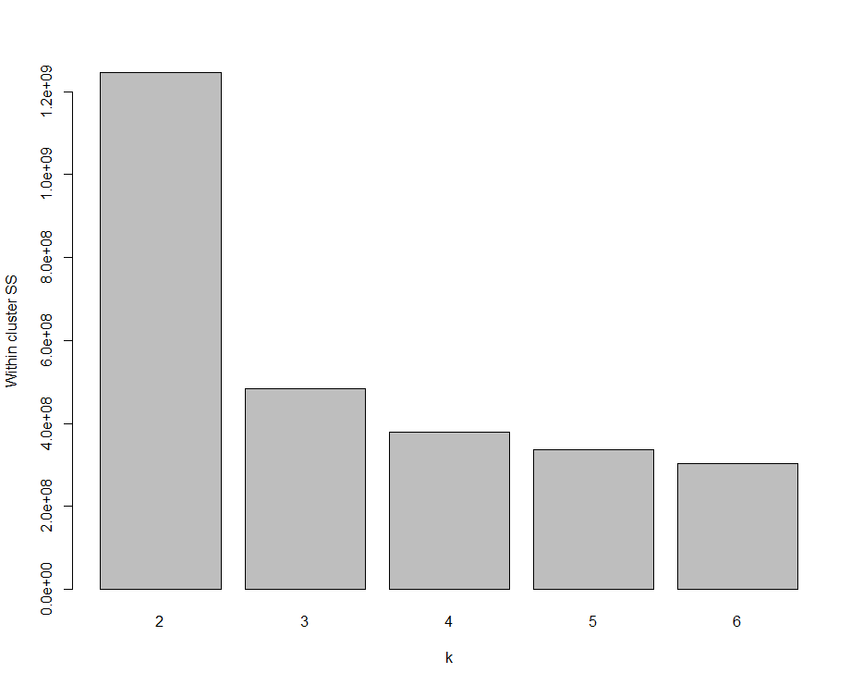
3. For the plot of FL2.H vs FL3.H I have chosen 3 cluster and FL3.H vs FL4.H I have chosen 4 clusters because above that problem of over clustering was coming.
4. 